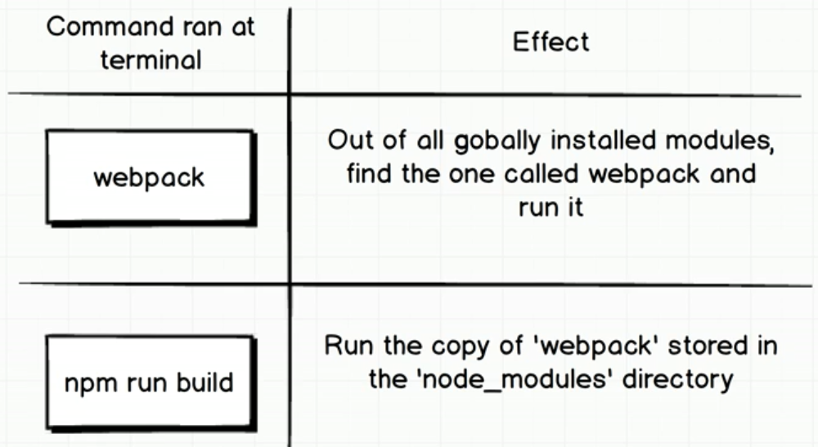

write inside package.json:

  "scripts": {

    "build": "webpack"

  }

Run webpack by executing script:

$ npm run build

if webpack_cli is installed, main.js will appear inside dist folder, this optimised file contains only one function that can run all functions inside the project

Snapshot of main.js:

!(function(e) {

    ...

)([

**// function calling inside entry**

    function(e, t, n) {

**// run the second element of current array**

        const r = n(1)(2, 6);

        console.log(r);

    },

**// second element**

    function(e, t) {

        e.exports = (e, t) => e + t;

    }

]);